Program 1:-

Linear Search::

#include<stdio.h>

int main(){

int n;

printf("enter the size of array: \n");

scanf("%d",&n);

int myArray[n];

printf("enter %d elements: ",n);

int i;

for(i=0;i<n;i++){

scanf("%d",&myArray[i]);

}int a;

printf("enter the element to search: ");

scanf("%d",&a);

int b=0;

for(i=0;i<n;i++){

if(myArray[i] == a){

printf("element %d found at index %d: \n",a,i);

b=1;

break;

}

}

if(b!=1){

printf("element %d is not found in array: \n",a);

}

return 0;

}

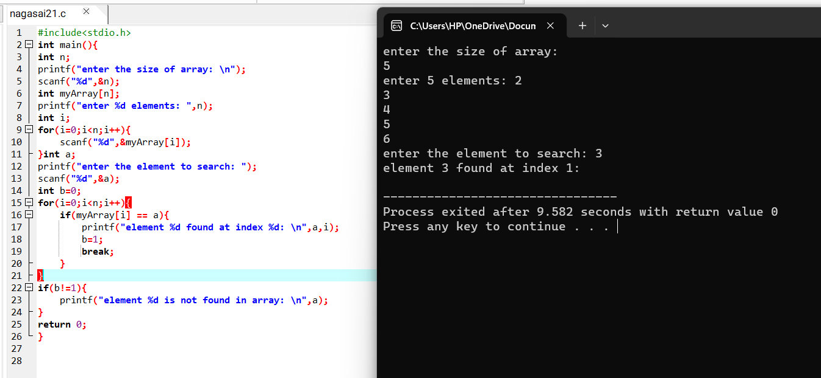

-------------------------------------------------------------------

Program 2:-

Binary search::

#include<stdio.h>

int main ()

{

int a[50],n,i,target,first,last,mid;

printf("enter the size of an array:");

scanf("%d",&n);

printf("enter the elements of array:");

for(i=0;i<n;i++)

{

scanf("%d",&a[i]);

}

printf("enter the element to search:");

scanf("%d",&target);

first = 0;

last = n-1;

mid = (first+last)/2;

while(first<=last)

{

if(a[mid]<target)

{

first = mid+1;

mid=(first+last)/2;

}

else if(a[mid]==target)

{

printf("the number %d found at position %d",target,mid+1);

break;

}

else

{

last = mid-1;

mid = (first+last)/2;}

}

if(first>last)

printf("the number %d not found in array ",target);

return 0;

}

